A)

The RGB Interpolation is much better for visualizing a continuous scalar variable. In the Image below each step away from the start is closer to what the end should look like. The HSL diagram goes through a range of different colors before reaching the desired color.

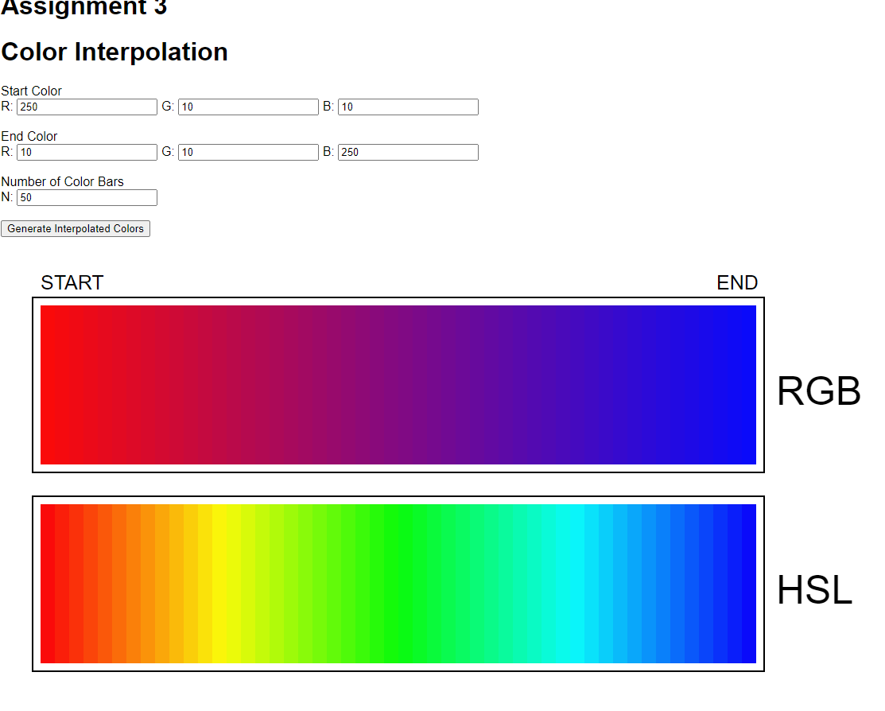

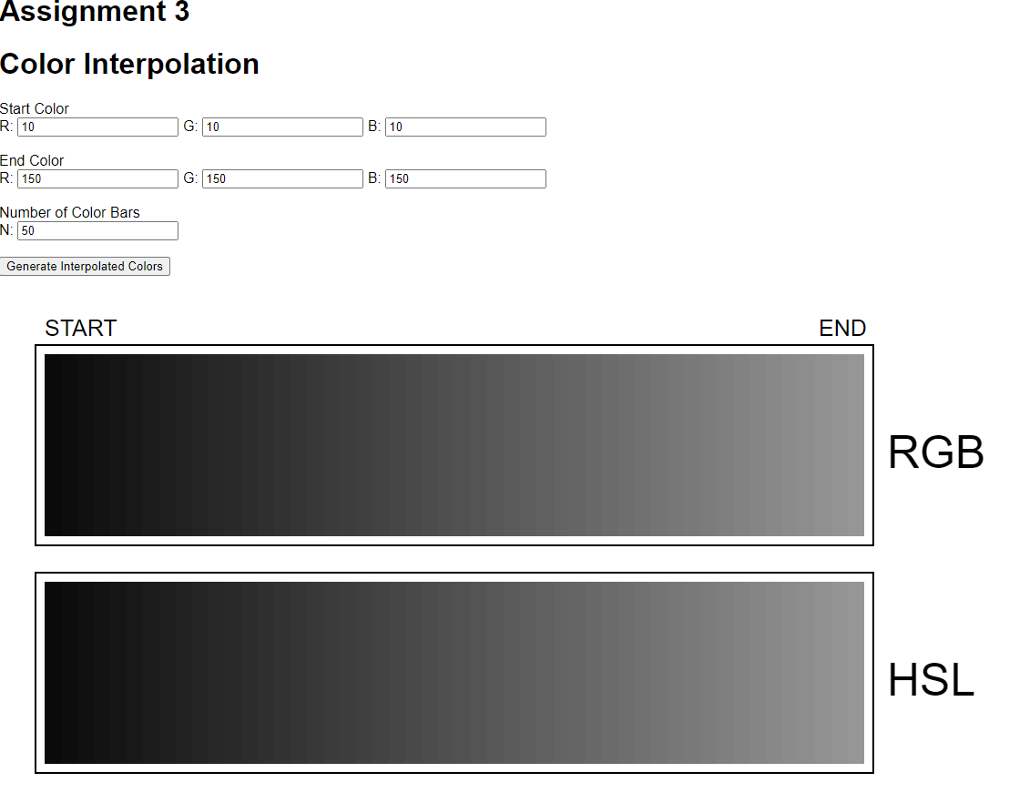

B)

C)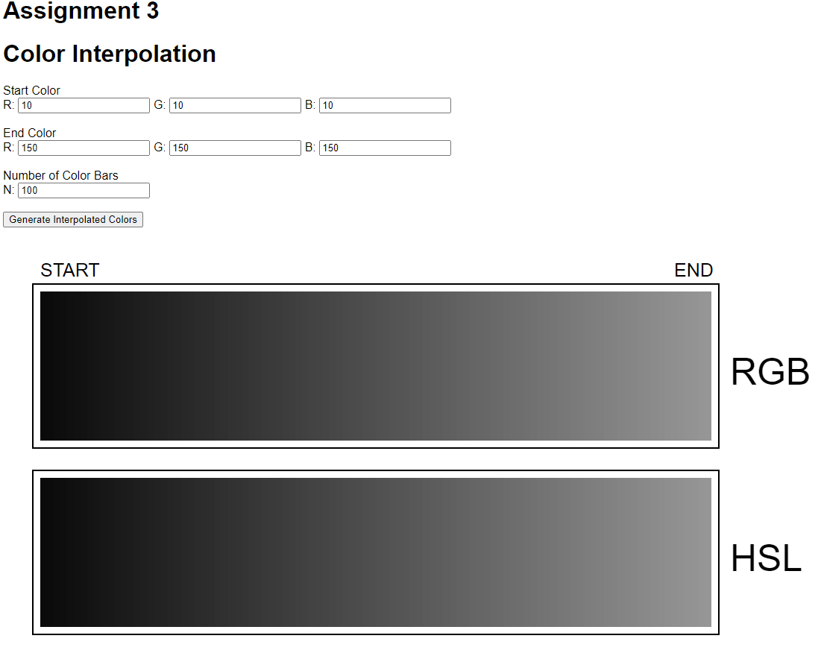

When the color is gray, it seems to be that around 100 both charts are equally smooth.

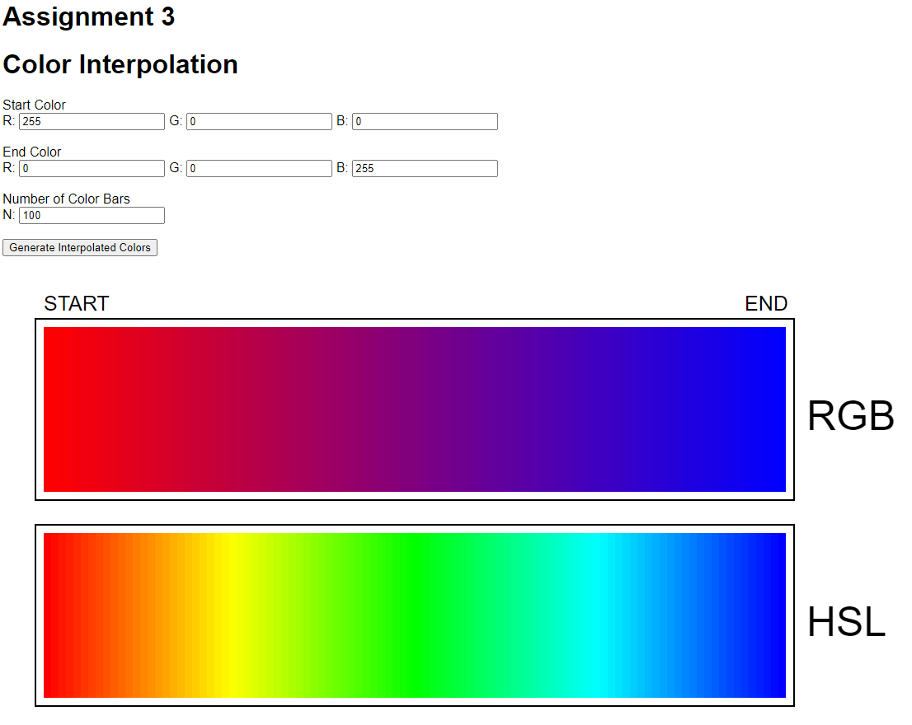

When the colors are on the opposite end of the spectrum, RGB really starts to look smooth at around 75-100. Meanwhile, HSL starts to look smooth at around double that of 200 bars.

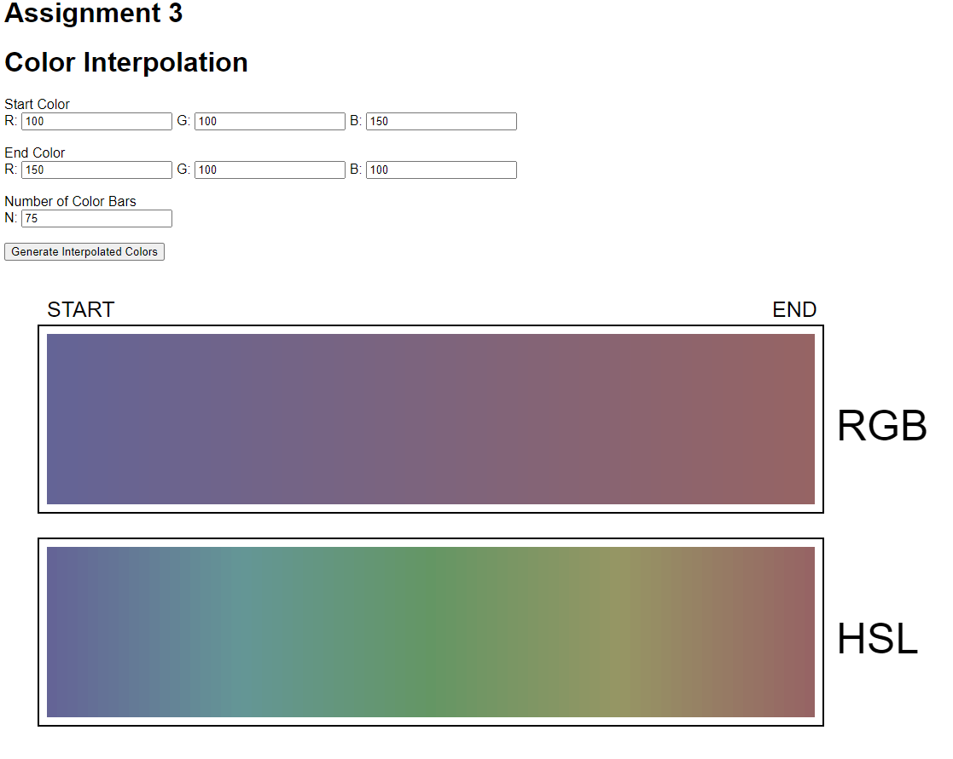

When the color values seem to be closer there seems to be a smaller number of required bars for both RGB and HSL to achieve Smoothness

2

a) Two distinctly different regions. What is the shape of the boundary?

b) Three outlier points. Where are they, and what are their values?

c) Which encoding (color or size) was most useful for answering a) and b)? What decisions did you need to make for each plot to get good results?

2A)

The shape of the boundary is a circle

2B)

Two outlier points are not in the circle at (81.2, 79.5) and (81.4, 78.5) and a p of 0.1 the other outlier point is in the circle at (29.3, 24.4) with a p of 9

2C)

There were pros and cons to each of the graphs. Getting the general shape and boundary of the graph was easy with both size and color. Though with color it was more distinct as some of the sizes can cloud the boundary shape as the size of the circles can make the graph overall hard to read. The problem with color is that there were some overlapping circles, therefore size was really handy in finding the overlapping outliers. With the overlapping outliers, I just changed the opacity of each dot on the scatterplot to make it viewable even though it isn’t perfect. A better solution would be to encode both in some way shape or form. But overall color is much better and much more helpful at consistently finding the values without the chart being too messy.

1. What question(s) are you trying to answer? (Domain situation) For example, are you comparing trends in the different fields, or looking for outliers across all fields?

I want to identify when they got their Highest degree Vs. the age when they got Nobel Prize. I want to see if there were potentially “uneducated” or “lower” educated Nobel Peace prize winners. Typically People aren’t allowed to get their Ph.D.’s and Doctorates until much later in life so seeing when people got their highest degree and their age can tell us a lot about the general standards of education that many Nobel prize winners get. I also want to see if people continue their education after their Nobel prize is awarded.

2. What data do you need to answer the question and did you need to perform any data transformations? (Data/task abstraction)

I needed to get the age of the individual at the time of the prize. I just subtracted the prize year from the birth year to get their age.

3. How did you choose to display your attributes? (Visual Encoding and Interaction Idiom)

I created a scatterplot as it was much easier to see when a specific person got their prize through the interaction idiom of mouse over a point in scatterplot which returns the name of the individual

1. What question(s) are you trying to answer? (Domain situation) For example, are you comparing trends in the different fields, or looking for outliers across all fields?

Which is more prevalent for physics, chemistry, and medicine, theoretical or empirical Nobel peace prizes

2. What data do you need to answer the question and did you need to perform any data transformations? (Data/task abstraction)

I needed to get the total number of winners in each category, I needed to figure out the number of empirical and theoretical peace prize winners and the percents of each

3. How did you choose to display your attributes? (Visual Encoding and Interaction Idiom)

I chose a bar graph. Both the clustered for specific numbers and the stacked 100% so we can compare percentages of theoretical and empirical between each

1. What question(s) are you trying to answer? (Domain situation) For example, are you comparing trends in the different fields, or looking for outliers across all fields?

Are Nobel prize winners older or younger as time goes on

2. What data do you need to answer the question and did you need to perform any data transformations? (Data/task abstraction)

I need to calculate the age. I also needed to find the women and encode their names into the page to ensure that we can look at does gender have any effect on this question

3. How did you choose to display your attributes? (Visual Encoding and Interaction Idiom)

I chose a scatterplot and gave it the ability to hover over to view names